• **ZENA RESORT HOTEL VISION**

**While providing quality experience to our guests, adding value to our stakeholders by applying sustainable tourism principles with the participation of all our employees, and being the first address of our guests when drawing their holiday routes.**

* **ZENA RESORT HOTEL MISSION**

**Our basic principle is to provide our guests with services that will make them feel special, without compromising their comfort, by respecting the environment and social values, by constantly improving and following innovations.**

**• ZENA RESORT HOTEL VALUES**

**• Openness and Transparency**

**• Professionalism**

**• Reliability**

**• Justice**

**• Productivity**

**• Teamwork**

**• Love and respect**

**• Environmental awareness**

* **OUR SUSTAINABILITY ROADMAP**
* **✓ OUR SUSTAINABILITY APPROACH**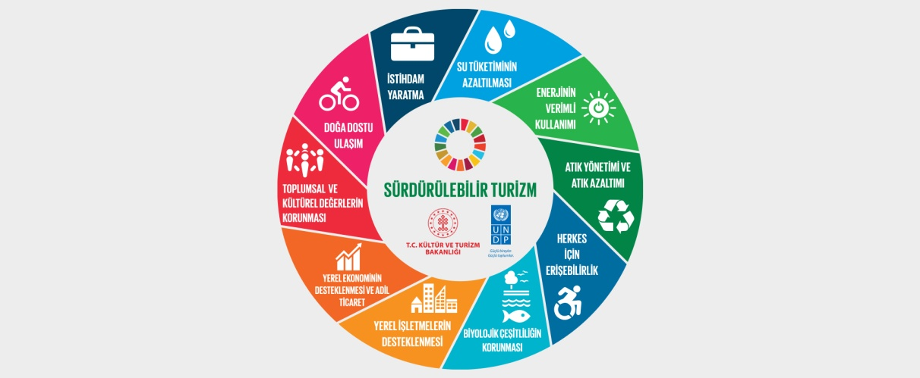

**RESPECT …**

**• In order to be respected in the world, we respect the environment and the Earth…**

**Zena Resort Hotel is a business that offers quality holiday opportunities to its guests, works to ensure that future tourist generations can use tourism resources without being consumed, polluted or emptied, and adopts the protection of all natural and cultural resources for local people and guests.**

**As Zena Resort Hotel family, the most important basis of our sustainable tourism policy is to create social awareness and develop conservation awareness regarding the protection of cultural and natural heritage areas.**

**OUR GOALS**

**➢ Improving communication with stakeholders**

**➢ Developing methods to share our sustainability efforts more effectively with stakeholders**

**➢ Optimization in Data Collection processes**

**➢ To review the resources used in data collection and carry out studies to create our goals in a way that will achieve more effective results.**

**➢ Zero Work Accidents: Ensuring that no work accidents occur by ensuring all occupational safety conditions for our employees and subcontractors.**

** About Nature and the Future,**

**We aim to meet the demands and expectations of guests and all relevant stakeholders with a perfect service approach. We ensured that our business adopted an effective management system that manages its environmental impacts. We adopt the development of future-oriented environmental and waste management practices.**

** We received the Zero Waste Certificate on 12.07.2019.**

** Regarding compliance with legal requirements,**

**We identify the relevant parties within our organization's sphere of influence and make the necessary plans to meet the expectations of each relevant party.**

**We ensure that all products and services offered comply with legal requirements and comply with all national and international legislation.**

**We determine legal and relevant regulatory requirements, constantly review them and develop innovative systems for full compliance with legal requirements.**

** Safe Tourism Certificate was received on 31.03.2021.**

** Regarding fair employment and human rights,**

**We provide a good and safe working environment for our employees. Gender, locality, age, education, belief, etc. in employment. We follow fair approach policies on issues and develop operating procedures that comply with working conditions and human rights.**

**All stakeholders have freedom of thought and belief, and we do not discriminate against anyone on issues such as language, religion, race, gender, social class, age and union membership. Protection of human rights is our fundamental rule.**

** About our Child-Friendly Approaches,**

**Our organization adopts the principles of strengthening a child-friendly, safe tourism approach in tourism and travel and developing awareness of children's rights. We manage our risks and opportunities in protecting and supporting children's rights and make the necessary plans to raise awareness of our employees on this issue.**

** Regarding the safety of employees and stakeholders,**

**We determine, lead, adapt and fulfill the requirements within the scope of Health, Safety, Food, Environment and Sustainable Development, Human Rights, Information Security, Occupational Health and Safety within the framework we have created in accordance with national and international laws and regulations.**

** Management of Risks**

**We manage the environmental impacts and dimensions, socio-cultural impacts, business and security risks of all the activities we carry out, and carry out planned studies to minimize the impact and maximize the benefit.**

**We address all elements aimed at meeting relevant party expectations appropriate to the context of our organization and effectively monitor related risks.**

** Regarding Guest Satisfaction,**

**Every feedback from our guests is very valuable to us. We consider the feedback we receive as an opportunity to change, improve ourselves and compensate if necessary.**

**We meet our guests' desires and requests in a transparent, accessible, responsive, impartial manner, while handling complaints, free of charge, information integrity and security, confidentiality level, customer-oriented, accountable, adopting continuous improvement in the guest establishment interface, with a proven team spirit, with our punctuality principles. We will consider.**

**We create awareness of Food Safety, Environmental Management, Human Rights, Information Security, Occupational Health and Safety in order to provide our guests with quality, safe and comfortable service in the most appropriate way for the Zena Resort Hotel brand.**

** Concerning the protection of natural life and the environment,**

**We aim to contribute to the development of the natural environment in all our activities. We develop projects to reduce the amount of waste within the scope of efficient use of resources, prevention of pollution and zero waste projects.**

**We tend to use materials that can be recycled and whose impact on nature can be reduced. We adopt activities that will reduce the climate crisis and support the protection of biodiversity and ecosystem.**

**By using the ozone washing system, we provide the most natural disinfection of vegetables and fruits, and we protect nature, the environment and human health by not using chemical products.**

** Regarding energy, water saving and footprint,**

**We adopt the most efficient use of energy resources and the use of alternative renewable resources. We aim to continuously improve our energy performance.**

**We adopt monitoring, improvement and efficiency projects to reduce our organization's water and carbon footprint.**

** Regarding hygiene and food safety,**

**Regarding food safety and hygiene, we embrace the protection of safety in the food chain from source to plate. We do not offer products for production and service without ensuring the suitability of suppliers. We operate subsystems that embrace continuous improvement regarding food hygiene in the business production and service areas.**

**For our guests to have a healthy diet; We offer physically, chemically and microbiologically clean foods. We comply with the laws and regulations published in our country in the purchase, storage, preparation and presentation of raw materials. Our goal is to constantly raise our food safety standards and ensure that they are implemented as a system. While developing our products and services, we take care to ensure that they are environmentally friendly, safe, durable and of high quality. To obtain all relevant certifications and security details for all our products and to maintain their sustainability with care.**

* ** Regarding copyrights and cultural heritage,**
* **We attach importance to copyrights and intellectual property rights in the social and cultural activities provided within our business. We prioritize preserving the cultural heritage of the Antalya Kemer/Çamyuva region and informing our guests about it.**
* ** On sustainable economy and supply chain management,**
* **We oversee the development of the supply chain with the desire to contribute to the local economy. We take care of the locality of our raw materials and monitor their improvement with statistical data. We prefer to work with suppliers that adopt fair trade, life cycle analysis, carbon footprint calculation and monitoring rules.**
* **We adopt preventive policies regarding the procurement and use of threatened species.**
* **We adopt that the products supplied are purchased from environmentally friendly products and suppliers.**
* **We take care to select the products supplied from reusable, recyclable or recycled and returnable products.**
* **Regarding personal data and general data security,**
* **The data of our employees and guests is safe with us. We ensure risk management regarding data security and ensure the implementation of technical and administrative measures with a continuously improveable infrastructure for the protection of personal data. We adopt the necessary care and operation and continuous improvement of subsystems to protect and safeguard data of the relevant person.**
* **Within the framework of this basic Sustainable Management policy, establishing, protecting, maintaining and ensuring continuous improvement of the management systems adopted by our organization are among our founding commitments.**